DBMS Learning Platform
Interactive Database Management System Learning Tool

📌 Project Links
🌐 Live Demo: https://dbms-project1.vercel.app/
💻 GitHub Repository: https://github.com/kri297/DBMS-PROJECT

📋 Project Overview
The DBMS Learning Platform is a comprehensive interactive educational tool designed to make database management concepts accessible and engaging through hands-on learning experiences. This platform features four essential modules that cover fundamental to advanced DBMS topics with real-time visualizations and interactive simulations.

✨ Key Features
🎨 Modern UI/UX Design
- Responsive design that works seamlessly across desktop, tablet, and mobile devices
- Dark and light theme toggle for comfortable learning in any environment
- Professional glass-morphism effects and gradient designs
- Smooth animations and transitions using AOS library
💾 Progress Tracking
- Automatic save/load functionality across all modules
- Client-side data storage for privacy
- Export/import capabilities for data backup
⌨️ Keyboard Shortcuts
- Ctrl + T - Toggle dark/light theme
- Ctrl + H - Show help modal
- Ctrl + 1-4 - Quick access to modules
- Esc - Close modals or menus
📱 Cross-Platform Compatibility
- Mobile-first responsive approach
- Adaptive layouts for all screen sizes
- Touch-friendly interface for tablets and smartphones
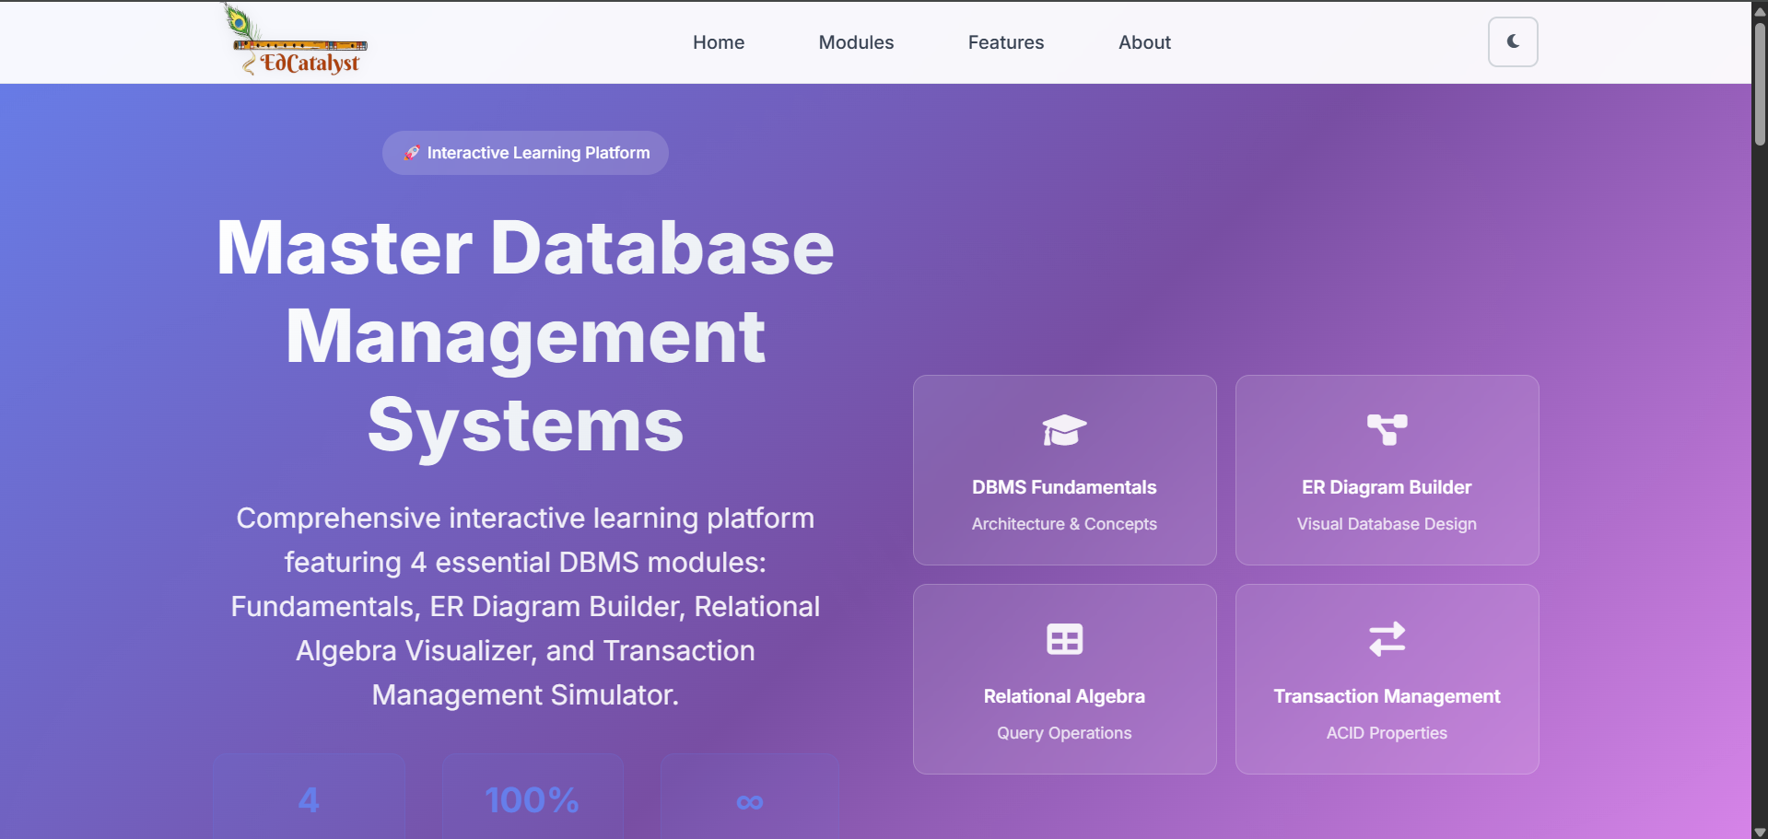

🎯 Core Modules
Module 1: DBMS Fundamentals
Architecture & Core Concepts
What it does:
- Provides comprehensive introduction to Database Management Systems
- Visualizes Three-Schema Architecture (External, Conceptual, Internal)
- Explains Schema vs Instance concepts with interactive examples
- Demonstrates advantages and features of DBMS over file systems
- Interactive navigation system for easy concept exploration
Learning Outcomes:
- Understanding of database architecture layers
- Grasp of fundamental DBMS concepts
- Knowledge of DBMS advantages in real-world applications
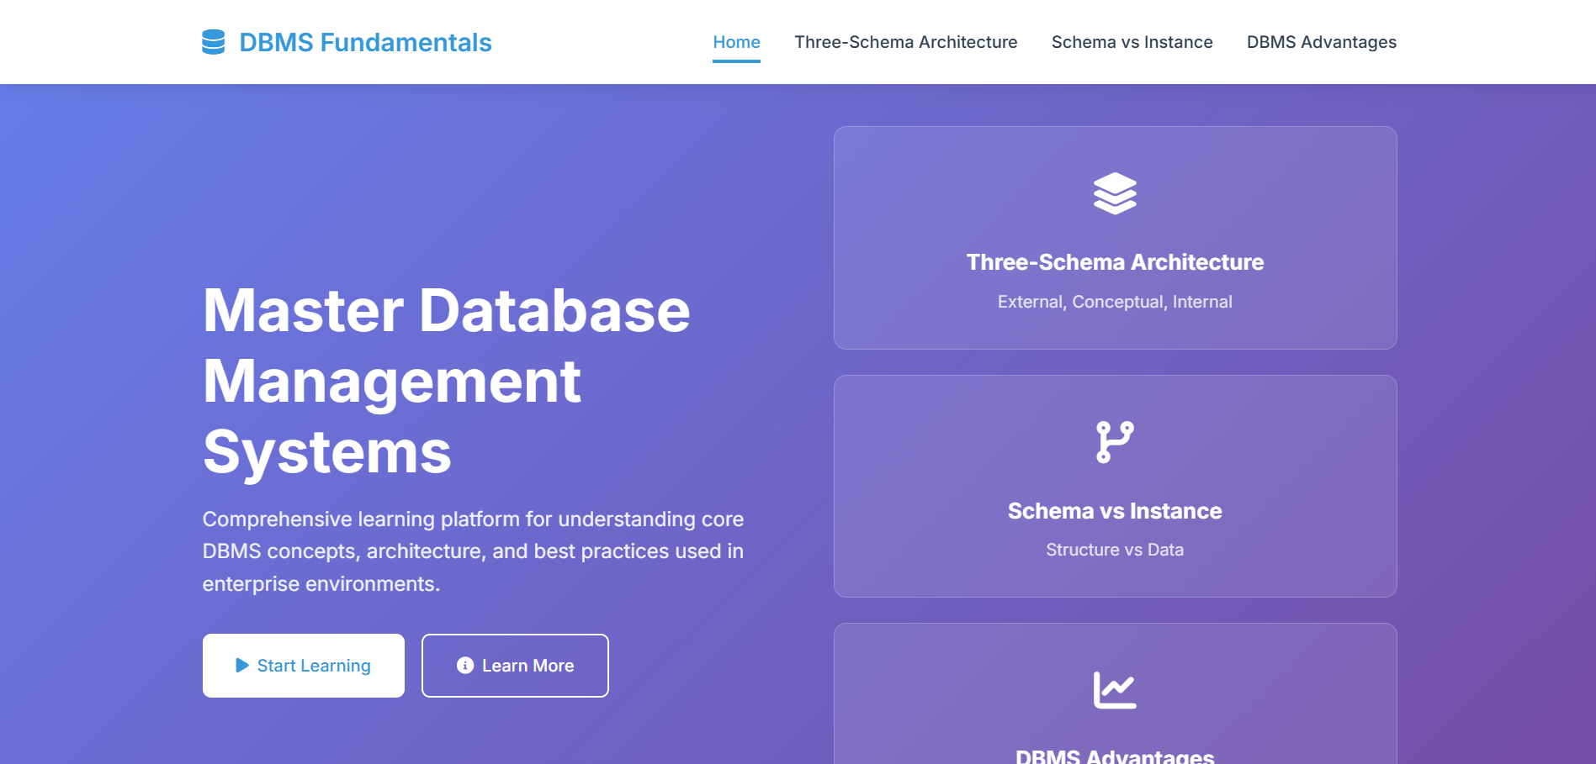
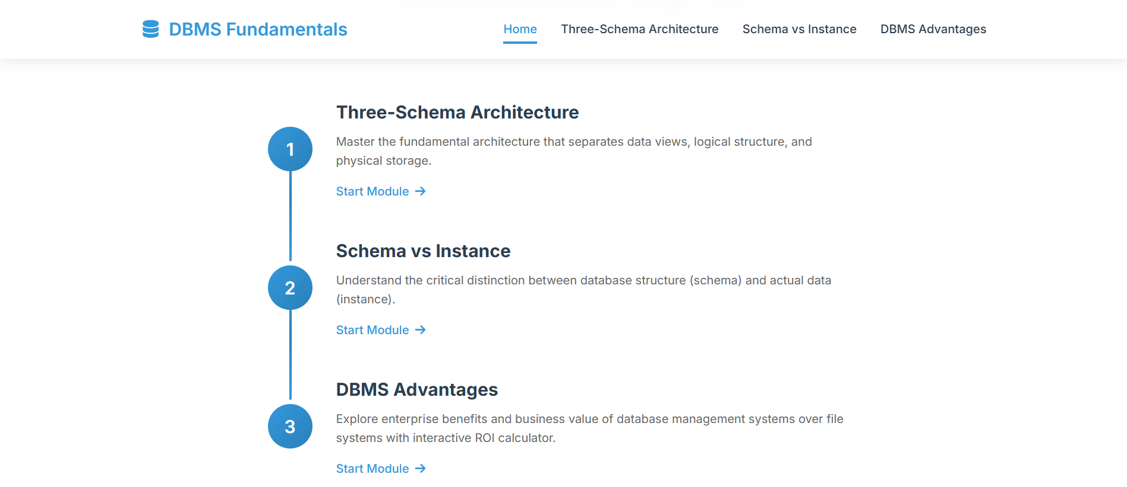

Module 2: Advanced ER Diagram Builder
Visual Database Design Tool
What it does:
- Professional drag-and-drop Entity-Relationship diagram builder
- Support for both ER and Enhanced ER (EER) diagrams
- Interactive entity and relationship creation
- Automatic SQL schema generation from diagrams
- Save and load diagram functionality
- Export diagrams in multiple formats
Key Capabilities:
- Create entities with attributes (simple, composite, multivalued, derived)
- Define relationships with cardinalities (1:1, 1:N, M:N)
- Support for weak entities and identifying relationships
- Automatic foreign key detection
- Generate SQL DDL statements from visual design

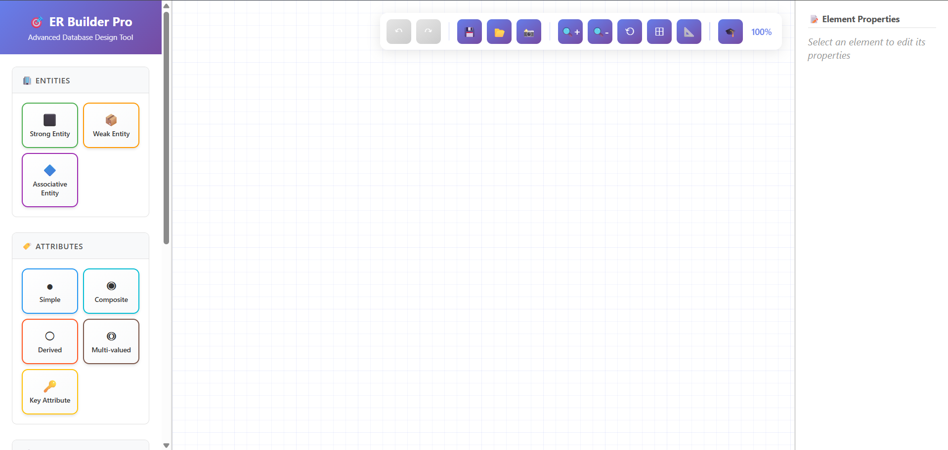
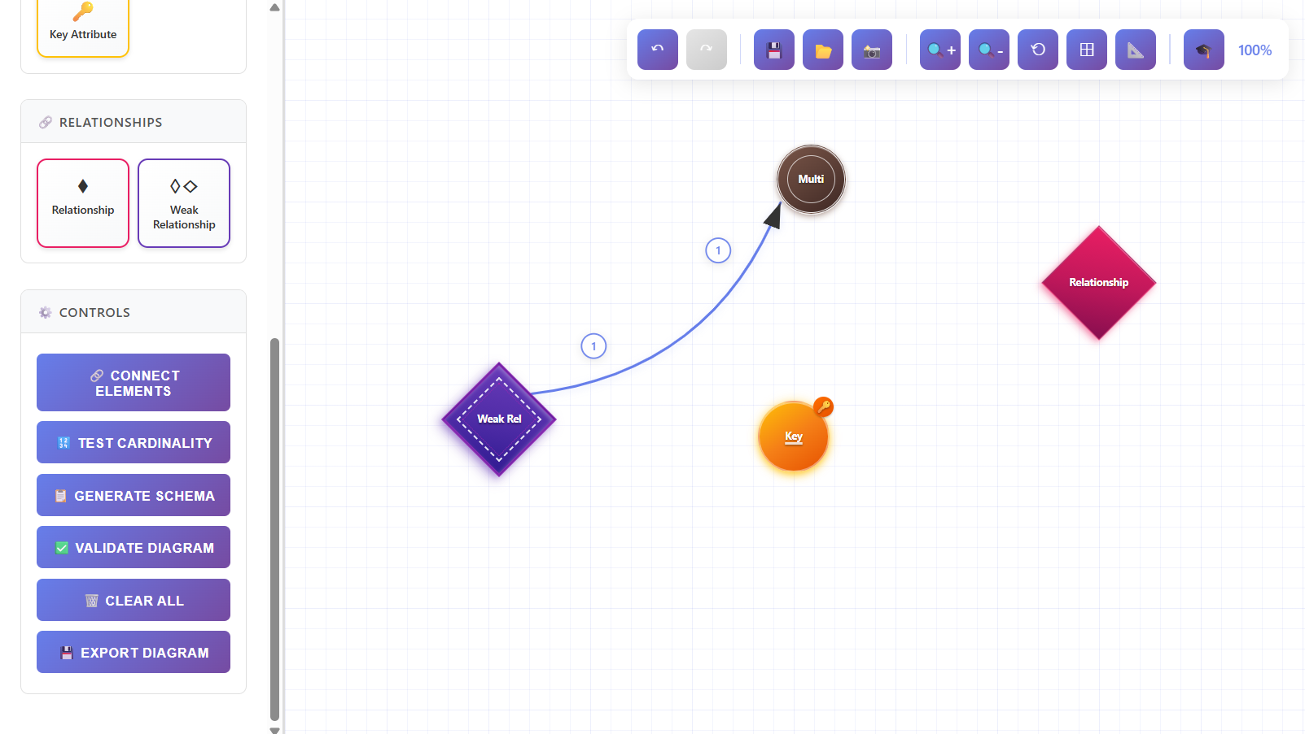

Module 3: Relational Algebra Visualizer
Interactive Query Operations Simulator
What it does:
- Create custom relations (tables) with sample data
- Apply fundamental relational algebra operations in real-time
- Visualize query results instantly
- Interactive tutorial system for guided learning
Supported Operations:
- SELECT (σ) - Filter rows based on conditions
- PROJECT (π) - Select specific columns
- JOIN (⨝) - Combine tables based on common attributes
- UNION (∪) - Combine results from multiple queries
- DIFFERENCE (−) - Find rows in one relation but not another
Learning Benefits:
- Understand query execution visually
- Practice relational algebra concepts hands-on
- Real-time feedback on operations
c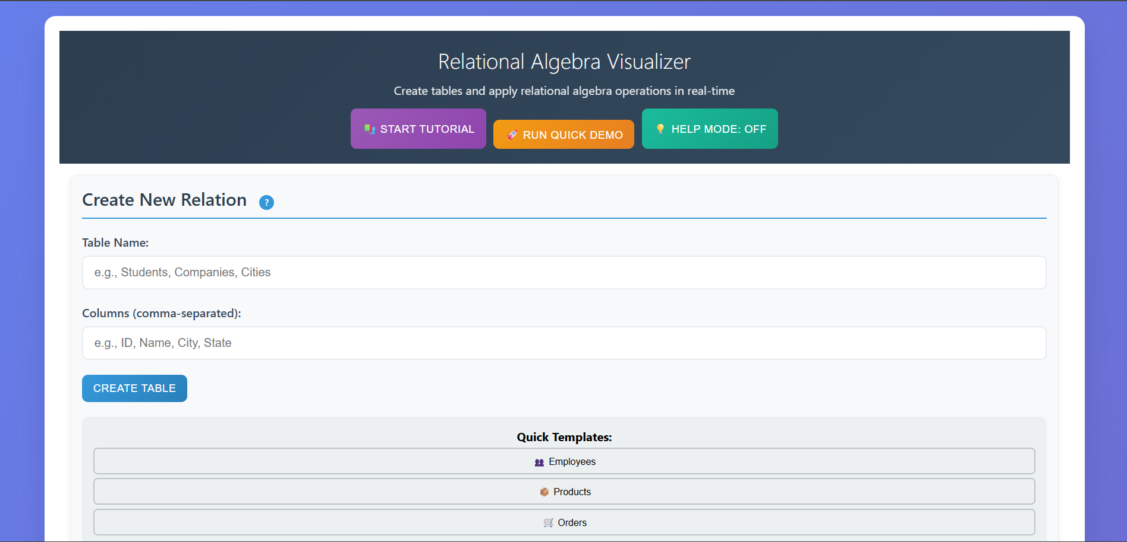
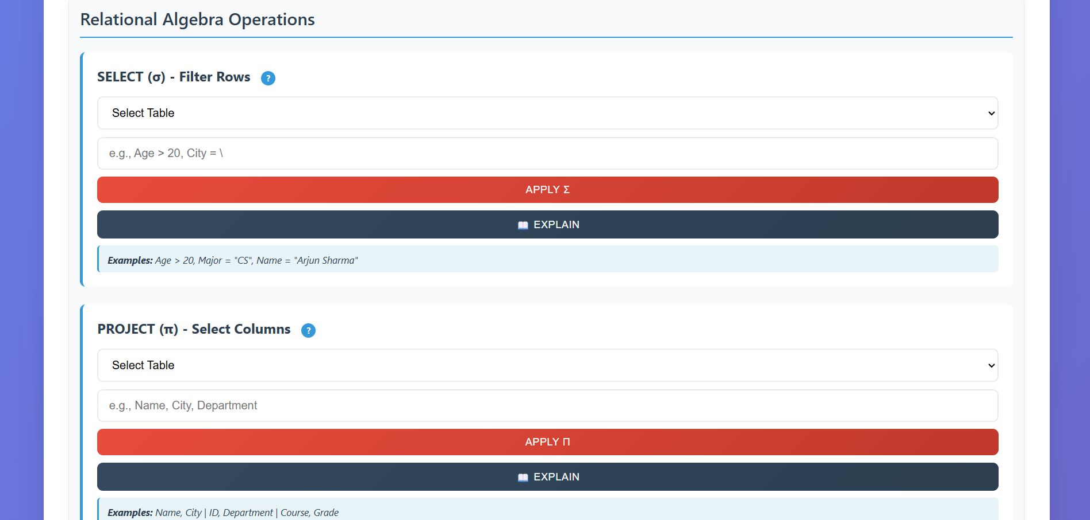

Module 4: Transaction Management Simulator
ACID Properties & Concurrency Control
What it does:
- Comprehensive simulation of transaction states and lifecycles
- Interactive demonstration of ACID properties
- Concurrency control examples and scenarios
- Dirty read and other anomaly demonstrations
- Privilege management system simulation
ACID Properties Covered:
- Atomicity - All-or-nothing transaction execution
- Consistency - Database integrity maintenance
- Isolation - Concurrent transaction independence
- Durability - Permanent transaction effects
Concurrency Issues:
- Lost updates
- Dirty reads
- Non-repeatable reads
- Phantom reads
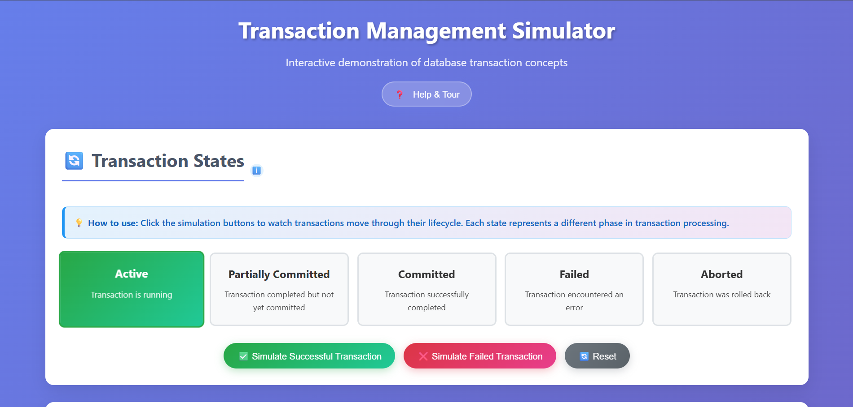

🛠️ Technologies Used
Frontend Technologies
- HTML5 - Semantic markup and structure
- CSS3 - Advanced styling with Grid and Flexbox
- JavaScript (ES6+) - Interactive functionality and logic
Styling & Design
- CSS Custom Properties for theming
- CSS Grid and Flexbox for responsive layouts
- Font Awesome 6.0 for icons
- Google Fonts (Inter) for typography
- AOS (Animate On Scroll) library for animations
- Glass-morphism and gradient effects
Deployment & Hosting
- Vercel - Static site hosting and deployment
- Automatic CI/CD from GitHub repository
- Global CDN for fast loading times

📂 Project Structure
DBMS-Learning-Platform/
├── index.html # Main landing page
├── styles.css # Comprehensive CSS styles
├── script.js # Interactive JavaScript
├── package.json # Project configuration
├── vercel.json # Vercel deployment config
├── README.md # Documentation
├── Q1/ # DBMS Fundamentals Module
│ ├── home.html
│ ├── css/
│ ├── js/
│ └── pages/
├── Q2/ # ER Diagram Builder Module
│ ├── advanced-er-builder.html
│ └── README.md
├── Q3/ # Relational Algebra Module
│ ├── index.html
│ ├── script.js
│ ├── styles.css
│ └── README.md
└── Q4/ # Transaction Management Module
├── index.html
├── script.js
├── styles.css
└── README.md

🎓 Educational Value
This platform is perfect for:
- Students learning Database Management Systems
- Educators teaching database courses with interactive demonstrations
- Self-learners wanting hands-on practice with DBMS concepts
- Professionals refreshing their database knowledge
- Course curricula integration for interactive learning modules

🚀 Performance Features
- Fast Loading - Optimized assets and lazy loading
- Smooth Animations - Hardware-accelerated CSS transitions
- Efficient Code - Modular JavaScript architecture
- Progressive Enhancement - Works on all modern browsers
- Accessibility - Keyboard navigation and screen reader support

🔒 Privacy & Data
- All data stored locally in browser (LocalStorage)
- No server-side data collection or tracking
- Progress tracking is entirely client-side
- Export/import for backup and data portability
- No personal information required or collected

💡 Future Enhancements
- Additional modules for normalization and indexing
- SQL query builder and executor
- Collaborative diagram editing
- More advanced transaction scenarios
- Video tutorials integration
- Quiz and assessment features

🤝 Contributing
This is an educational project open for:
- Bug reports and issue tracking
- Feature suggestions and improvements
- Educational content contributions
- Sharing with students and educators

👨‍💻 Project Information
Built with ❤️ for database education
Repository: kri297/DBMS-PROJECT
Deployment Platform: Vercel
Last Updated: 2025

📸 Screenshots
Main Landing Page
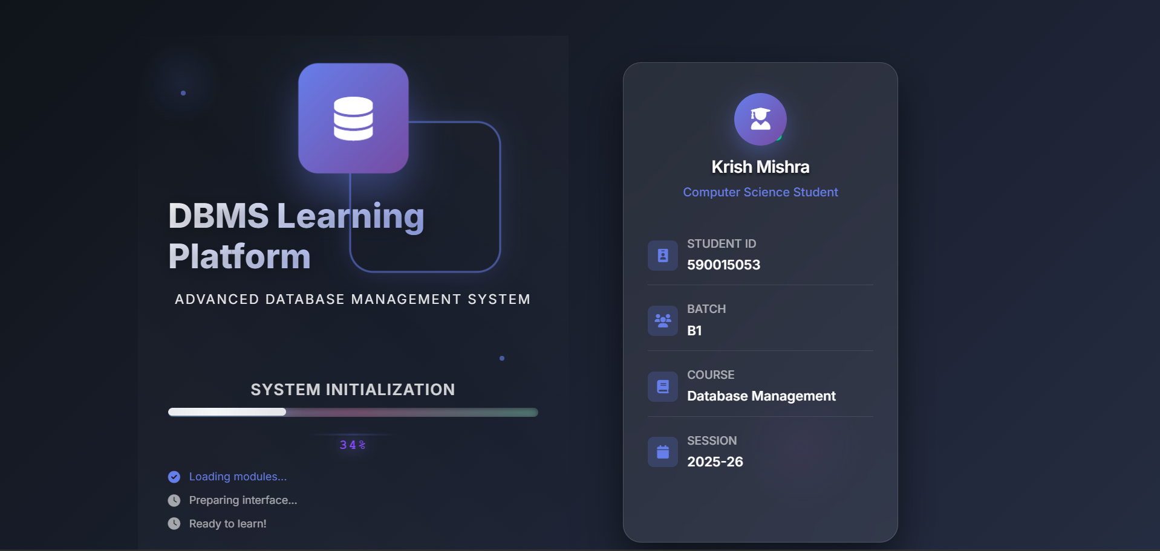

🎯 Conclusion
The DBMS Learning Platform represents a modern approach to database education, combining theoretical concepts with practical, interactive tools. Through its four comprehensive modules, users can gain hands-on experience with essential database management concepts in an engaging and visually appealing environment.

Get Started: Visit https://dbms-project1.vercel.app/ to explore the platform!
View Source: Check out the code at https://github.com/kri297/DBMS-PROJECT

